Project Design Phase-II Data Flow
Diagram & User Stories
Date | 15 October 2022
Team ID | PNT2022TMID42340
Project Name | Nutrition Assistant Application
Maximum Marks | 4 Marks
Data Flow Diagrams:
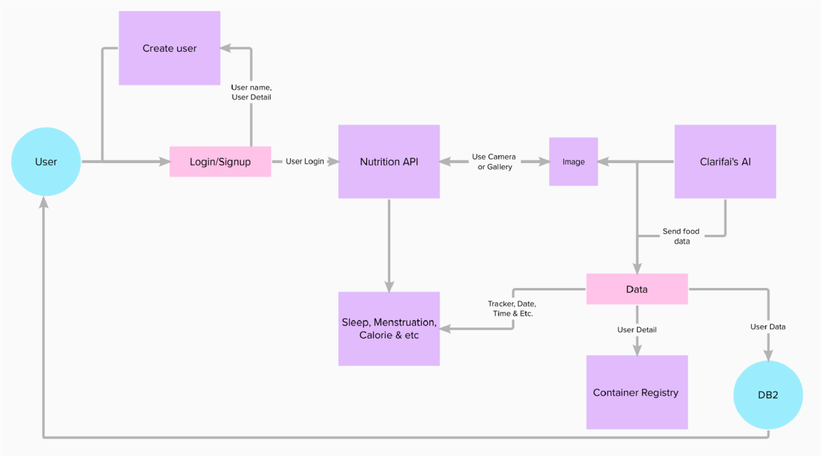
User Stories
Use the below template to list all the user stories for the product.
User Type | Functional  Requirement  (Epic) | User Story Number | User Story / Task | Acceptance criteria | Priority | Release
Customer | Registration | USN-1 | As a user, I can register for the application by entering my Name, Age, Gender, E-mail, password, and confirming my password. | I can access my account / dashboard. | High | Sprint-1
 | Registration | USN-2 | As a user, I will receive confirmation email once I have registered for the application | I can receive confirmation email & click confirm. | Medium | Sprint-1
 | Profile updating | USN-3 | As a user, I have to enter my height, weight and daily activity details. | I can update this  information on Dashboard | High | Sprint-1
 | Login | USN-4 | As a user, I can login to the application by entering E-mail and password. | I can access my account/ dashboard | Medium | Sprint-2
 | Database | USN-5 | As a user, I can upload or capture live image of the meal | I can get the nutritional value of that particular meal. | High | Sprint-2
 |  | USN-6 | As a user, I can track my daily calorie intake. | I can access my account/ Dashboard. | Medium | Sprint-2
Administrator | Maintaining details for users. | USN-7 | Maintaining details for users. | I can access database | High | Sprint-3
 | Security | USN-8 | As a user, I feel the site is very secure. | I can access my account with my login credentials. | High | Sprint-3

